***Guidelines for Final Project – Part I***

***\*\*Please note this is only part of the guidelines, as the semester continues, you will be provided with even more information\*\****

1. **Overview**: Each student or student group will give an oral presentation describing their analysis of an NGS dataset. These presentations will be given by the student(s) on April 27th, May 2nd, or May 4th. All students are expected to be present for the entire session, provide feedback, and ask questions to the presenter. In addition, each student will be expected to attend an additional session and provide feedback to student groups anonymously. Student’s will be asked to select a trail and rationalize why the trail was selected to Dr. Rodriguez. The trail selected will guide the overall goal of the analysis for the NGS dataset downloaded from GEO.
2. **Trails:** Ski trailsnamed and rated with different colors to signify to the skier the level of difficulty. In these trails, green signifies entry or beginner, blue signifies intermediate, while black signifies expert.

Similarly, the final project for this course will mirror these ratings with the understanding that within this class there are levels of expertise that range.

**Trail 1: Green Mountain Trail**

**“Replicate figure(s) in a primary research article and then change one parameter at the visualization stage”**

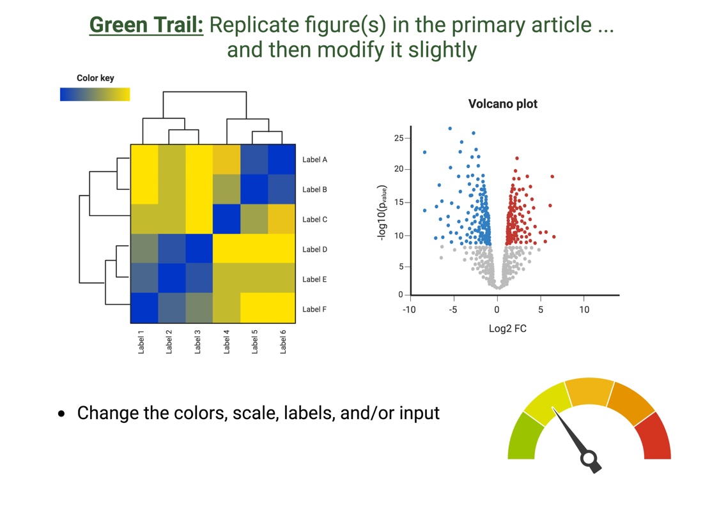

**Trail 2: Blue Sky Trail**

**“Compare and Contrast select parameters within the NGS pipeline and describe how this impacts your final output”**

**Trail 3: Black Diamond Trail**

**“Process and Download an NGS dataset to test an original hypothesis”**

**How do you Select A Trail?**

1. **General:** 
   1. Undergraduate students will be allowed to work in groups. No more than 3 students per group. This is an individual assignment for graduate students unless given permission.
   2. Each student project will be allocated 15 minutes to present their findings and answer questions from the audience. The audience will be able to ask you questions ***during*** the presentation.
   3. All team members must speak for the same amount of time and be ready to answer questions.
2. **Presentation content & Grading Rubric**: This will be provided to students in the March 2nd class and will posted on Blackboard and on the course website: (<https://prodriguez19.github.io/Intro-to-rnaseq/>)
3. **While selecting a primary research article, please consider the following:**
   1. NGS data type selection:

|  |  |
| --- | --- |
| **Acceptable** | **Unacceptable** |
| RNA-Seq | Single-cell RNA-Seq |
| ChIP-Seq | Single-cell ATAC-Seq |
| ATAC-Seq (permission required) | Microarray |
| Research-specific dataset (permission required) | Small RNA-Seq |

* 1. Organism: I will provide the indexed genome for mm10, hg38, and hg19 for HISAT2 and STAR alignment*
  2. Number of biological replicates available: at minimum 3-4 replicates per group is required (RNA-Seq), 2-3 for other data types
  3. Date of publication: 2000 to 2023
     1. Would prefer within the past 10-15 years but an older dataset will be considered

1. **Timeline for Part I :**

|  |  |  |  |  |
| --- | --- | --- | --- | --- |
|  | **Selecting a dataset** | **Download dataset** | **Index Genome** | **Alignment** |
| **Estimated time to complete** | 1-2 weeks | 24 hours | 1hr – 3 days | 3-7 days + |
| **Comment** |  | Per 5GB = 1.5 hrs = one sample | Depends on how large the genome is  Dependent on alignment strategy | Dependent on the number of samples |
| **Homework Assignment** | ~50 points  Justify why dataset and trail was selected | ~100 points  FASTQC + interpretation |  | ~100 points  Alignment stats  + interpretation  Decision to be made on ***how*** to proceed based on interpretation |
| **Due dates**  **(tentative)** | Feb 21st | Feb 27th |  | March 10th  (*sometime before Spring break*) |

1. **Important Disclosures**

* **While in-class, we will be going through the basic steps of data processing using a dataset that I have analyzed.**
* **This project requires that you use what you learned in-class and apply it to a different NGS dataset.**
* **I will not know the quality of the dataset selected until about March. Therefore, depending on what we find we may need to pivot and change the intention of the final project goals.**
* **I am most with advising on a human or mouse system. However, other organisms are completely fine to select, however you will be in charge of understanding if for example “*…there are pathway analysis tools available for Drosophila…”***
* **We will hit some unforeseen hiccups – this is completely normal in the realm of bioinformatics!**
* **I do not have control over how fast or slow your data will process on the VACC. The alignment step is the most COMPUTATIONAL HEAVY STEP of the ENTIRE pipeline. Please do not leave this for the last minute as the VACC will have multiple users!**